For Immediate Release
Contact: Mike Ruzicka
414.778.4929 or 414.870.1874
mike@gmar.com
March 13, 2025

February Home Sales Down 3.9%

Highlights
- Sales Down 3.9% in February
- Listings Up 0.4%, for the 3rd Straight Month
- Average Sale Price Up 15.5%

February Sales
County | 2024 | 2025 | % Change
Milwaukee | 619 | 551 | -11.0%
Waukesha | 225 | 244 | 8.4%
Ozaukee | 48 | 50 | 4.2%
Washington | 83 | 92 | 10.8%
Metro Area | 975 | 937 | -3.9%
Racine | 143 | 126 | -11.9%
Kenosha | 81 | 101 | 24.7%
Walworth | 79 | 72 | -8.9%
SE WI Area | 1,278 | 1,236 | -3.3%
February Listings
County | 2024 | 2025 | % Change
Milwaukee | 810 | 818 | 1.0%
Waukesha | 320 | 321 | 0.3%
Ozaukee | 77 | 85 | 10.4%
Washington | 144 | 133 | -7.6%
Metro Area | 1,351 | 1,357 | 0.4%
Racine | 159 | 192 | 20.8%
Kenosha | 146 | 100 | -31.5%
Walworth | 152 | 107 | -29.6%
SE WI Area | 1,808 | 1,756 | -2.9%
Market Summary
The Metropolitan Milwaukee housing market fell almost 4% in February, with 38 fewer sales than a year earlier.

February is usually a slow month, but only eking out 937 sales is less than would be expected considering the demand that exists.

As we move into the spring market it is encouraging that listings rose in February, although slightly, by 0.4%. That’s the third month in a row that listings have increased.

In fact, listings have increased in sixteen of the last nineteen months, but that was after one of the worst period of anemic listings (2022-2023) the market has seen this century.

When interest rates went up in mid-2022, sellers pulled back from listing their home for fear of paying higher interest rates on a new house. The result was fewer homes for buyers to choose from and a lot of frustration.

With listings lagging to the point that the market needs 5,265 more houses to meet current demand, the only place to look for those homes is new construction.

Unfortunately, the new homes side of the ledger has been unable to meet demand for years.

Through the end of 2024 there were 2,151 permits for new construction in the four county area. Well below the 5,265 new homes and condos the market needs today. In January there were only 144 new home permits taken out in the four county area – flat from January 2024.

Apart from the lack of adequate new construction and listings, demand for homes continues to remain strong.
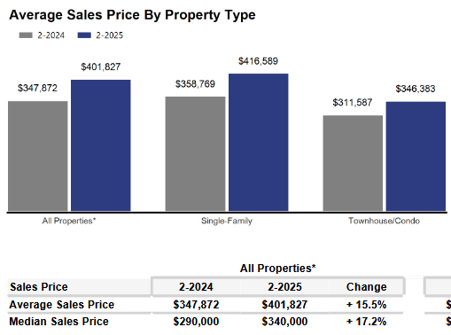
As economic law dictates, when there is high demand for a product and low supply, the cost goes up. And due to the current levels of demand and supply, the average home sale price in the four-county area went up 15.5% in February, from $347,872 in 2024 to $401,827 in February 2025.


That demand is being created by buyers who want all of the quality of life benefits that homeownership offers, so they are stretching to qualify for a loan, or come up with enough cash to get a house.

As we have been highlighting for several years – REALTORS® have had an exceedingly challenging time helping home buyers find ownership opportunities in the form of condos and single-family houses. This results in thousands of would-be homeowners forced to stay in rental units, unable to save for a down payment and foregoing the opportunity to build wealth through a home’s equity.

Where to go
Buyers should seek the counsel of a REALTOR® in determining their best housing options, and sellers need the expert advice of a REALTOR® in making correct marketing decisions for their home.

The Greater Milwaukee Association of REALTORS® is a 5,500-member strong professional organization dedicated to providing information, services, and products to help REALTORS® help their clients buy and sell real estate. Data for this report was collected by Metro MLS, Inc., a wholly owned subsidiary of GMAR.

* Sales and Listing figures differ between the “Monthly Stats” and quarter or year-end numbers, because the collection of Monthly Stats ends on the 10th of each month, whereas quarters are a continuous tally to 12/31. For example, if a sale occurred on the 29th of the month, but an agent does not record the sale until the 5th of the next month, that sale would not be included in the sales figures of the reported month (or any subsequent month’s total) but would be added to the quarterly and annual total sales figures.

** All references to the “metropolitan” area denotes the four counties of Milwaukee, Waukesha, Ozaukee, and Washington Counties. The “region” or “Southeast Wisconsin” refers to the four metropolitan counties (Milwaukee, Waukesha, Ozaukee, and Washington), plus Racine, Kenosha, and Walworth Counties, to the south.

Seasonally adjusted inventory tells us how many months it would take to sell the existing homes on the market. The seasonally adjusted inventory level for February was 2.3 months. Subtracting 1,177 “active offer” listings from those available for sale (about 80% of listings with an offer sell) yields 2,602 listings, which equals 1.0 months of inventory.

With 3,172 current listings providing 2.3 months of inventory, the market would need an additional 5,265 units to push inventory to six months. Six months of inventory is considered a “balanced” market. If inventory falls below six months, the market favors sellers, and when inventory exceeds six months, it is a buyer’s market.

